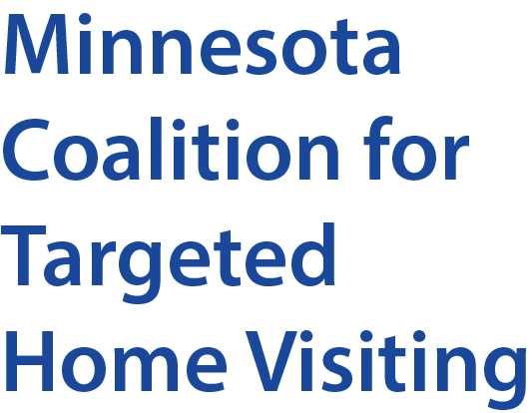

Quarterly Meeting Agenda
Zoom Meeting (Computer or Tablet)
https://zoom.us/j/946511346
Join by Phone: 1-312-626-6799
Meeting ID: 946 511 346

Thursday, March 26, 2020
12:00-1:30 PM
ONLINE via Zoom
TIME | AGENDA ITEM | NOTES
12:00 PM | Welcome/Introductions  Name, Organization, Answer Question:  What type of Home Visiting Services do you/your organization provide? | MCTHV Archived Trainings can be found at: http://www.targetedhomevisiting-mn.org/training
12:15 PM | Business Updates – Laura L-D and Etonde A  - Executive Team Update (Membership and Co-Chair)  - Legislative Session  - Greater MN Outreach & Engagement  - 2020 Budget & Fiscal Host
12:30 PM | Home Visiting Program Guidance and Q & A – Dawn Reckinger, Minnesota Department of Health  MDH will highlight key elements of the guidance for home visiting programs during COVID-19 pandemic - followed by a question & answer session.
1:05 PM | 2020 Census – Engaging Home Visitors & Early Childhood Organizations – Jennifer Bertram, Children’s Defense Fund MN  Learn how home visitors and home visiting programs can help educate families about the 2020 Census and the importance an accurate count has on home visiting and early childhood services for families, communities and the State of Minnesota.
1:30 PM | Adjourn

